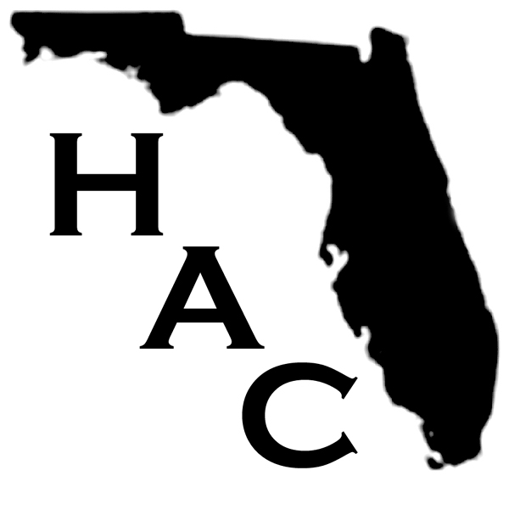
H.A.C. FLORIDA, INC.
Homeowners Against Citizens Insurance
ALL FLORIDA PROPERTY OWNERS

• Has your property insurance increased?
• Are you being forced out of your home due to the higher insurance rates?
• Do you think that the increases are too high and unfair?
• Will you be facing foreclosure on your home due to the insurance increases?
• If you don’t have Citizens Insurance do you think you should have to pay to bail them
out by an assessment your private insurer must add to your premium?
• Will you be able to sell your house if you can no longer afford it?

If you answered “yes” to any of these questions consider joining our organization in fighting Citizens Insurance and the exorbitant increases we are all being subjected to.
(While Citizens is our primary issue, all insurers are now included as they follow what happens with Citizens, as Citizens “sets the bar” for insurance in Florida.)

What is Homeowners Against Citizens Insurance?

HAC is a NON-PARTISAN, non-profit, grassroots organization of concerned people fighting against the skyrocketing insurance premiums in Florida and for total reform of the government agency "insurer of last resort" (Citizens Property Insurance). Citizens was created to enable people to obtain mortgages and purchase homes in Florida is now having the opposite effect. Why? Property insurance in the state of Florida has become so expensive in just the last year that many homeowners are losing their homes because they can't afford the new exorbitant rates. This is not only due to the insurance claims in the past two years but mostly because of mismanagement, fraud, conflict of interest, government gone wrong, incompetence and a multitude of other issues, as we see it.

Are we angry? You bet we are. And we intend to be heard. Insurance premiums that double and triple in a single year are backbreaking financially to homeowners and inexcusable no matter what the reason/excuse they try to hand out to us.

Hundreds, maybe thousands of homeowners stand a chance of losing their homes, possibly very soon, due to foreclosures and/inability to sell their home. Seniors, the disabled, people with minimal or fixed incomes, and others, may have nowhere to go and no means to fight-back against what is happening to them. People now have to decide whether to buy their medicines, food, gas for the car, clothing or pay the outrageous insurance premiums being forced upon them so they can keep their homes.

We must all stand together and be heard. So please consider joining HAC and the fight against skyrocketing insurance premiums in Florida.

For more information and to be included in all news and updates please visit our
HAC website at: www.hacfl.org ~ email: hac@hacfl.org
or mail us at: H.A.C., P.O. Box 395, Port Richey, Fl 34673

Also contact your State Senator or Representative. A link can be found at our website or at: www.myfloridahouse.gov

